studbud - ai Study Planner

# team name

“Mind Mates”

# Team Members

B.Sreeja

D.Poojitha

K.Poojitha

S.Sushmitha

# Phase - 1 : Braninstroming & ideation

Objectives:

To conceptualize an AI-powered study planner that enhances student learning efficiency through personalized scheduling, adaptive strategies, and smart recommendations.

Key Points:

1. Problem Statements:

* Poor Time Management: Students face difficulties in organizing study schedules, leading to procrastination and last-minute cramming.
* Lack of Personalization: Traditional planners fail to adapt to individual learning needs, resulting in ineffective study strategies and low motivation.

1. Proposed Solution:

* An AI-powered application that generates dynamic study plans based on syllabus, deadlines, and learning styles.
* The app provides real-time progress tracking and personalized recommendations.

1. Targets:

* Students preparing for competitive exams
* High school and college students looking for optimized study schedules.
* Learners needing adaptive study recommendations.

1. Expected output:

* A functional AI-powered study planner that helps students improve time management, retention, and overall academic performance.

# Phase - 2 : Reqiurement Analysis

Objective:

Define the technical and functional requirements for the StudBud AI Study Planner.

Key Points:

1. Technical Requirements:
   * + **Programming Language:** Python
     + **Backend:** Google Gemini Flash API
     + **Frontend:** HTML , CSS
     + **Database:** Not required initially (API-based queries)
2. Functional Requirements:
   * + AI-generated study schedules based on syllabus and deadlines.
     + Personalized learning recommendations based on user performance.
3. Constraints & Challenges:

* Ensuring real-time updates and accurate recommendations.
* Designing an intuitive and engaging UI for student usability.

# Phase - 3 : project Design

Objective :

Develop the architecture and user flow of the application.

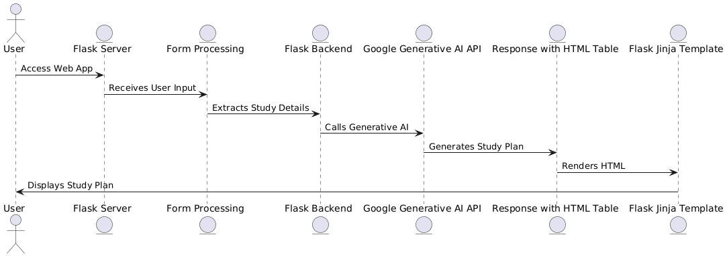

Key Points :

* 1. System Architecture :
     + User enters study-related query via UI.
     + Query is processed using Google Gemini API.
     + AI model fetches and processes data.
     + The frontend displays customized study schedules and learning insights.
  2. UserFlow :
     + Step 1 : User inputs subjects, syllabus, and deadlines.
     + Step 2 : AI generates a personalized study plan.
     + Step 3 : It initially gives a generalized approach .
     + Step 4 : Website displays the schedule , subject-wise breakdown , revision strategies and additional tips.

* 1. UI / UX Consideration:
     + Minimalist, user-friendly interface with easy navigation.
     + Dark & light mode for better user experience.
     + Interactive progress tracking dashboard.

## **Phase-4: Project Planning (Agile Methodologies)**

**Objective:**

Break down development tasks for efficient completion.

|  |  |  |  |  |  |  |  |
| --- | --- | --- | --- | --- | --- | --- | --- |
| **Sprint** | **Task** | **Priority** | **Duration** | **Deadline** | **Assigned To** | **Dependencies** | **Expected Outcome** |
| Sprint 1 | Environment Setup & API Integration | 🔴 High | 6 hours | End of Day 1 | Sushmitha  & D.Poojitha | Google API Key, Python, Streamlit setup | API connection established & working |
| Sprint 1 | Frontend UI Development | 🔴 Medium | 2 hours | End of Day 1 | Sreeja | API response format finalized | Basic UI with input fields |
| Sprint 2 | Study Plan Generation | 🔴 High | 3 hours | Mid-Day 2 | K.Poojitha | API response, UI elements ready | AI-based study planner working |
| Sprint 2 | Error Handling & Debugging | 🔴 High | 1.5 hours | Mid-Day 2 | Sushmitha  & D.Poojitha | API logs, UI inputs | Improved API stability |
| Sprint 3 | Testing & UI Enhancements | 🔴 Medium | 1.5 hours | Mid-Day 2 | K.Poojitha & Sreeja | API response, UI layout completed | Responsive UI, better user experience |
| Sprint 3 | Final Presentation & Deployment | 🔴 Low | 1 hour | End of Day 2 | Entire Team | Working prototype | Demo-ready project |

Sprint Priorities:

Sprint 1 – Setup & Integration (Day 1)

🔴 High Priority: Set up the environment & install dependencies.

🔴 High Priority: Integrate Google Gemini API.

🔴 Medium Priority: Build a basic UI with input fields.

Sprint 2 – Core Features & Debugging (Day 2)

🔴 High Priority: Implement search & comparison functionalities.

🔴 High Priority: Debug API issues & handle errors in queries.

Sprint 3 – Testing, Enhancements & Submission (Day 2)

🔴 Medium Priority: Test API responses, refine UI, & fix UI bugs.

🔴 Low Priority: Final demo preparation & deployment.

## **Phase-5: Project Development**

Objective :

Implement core features of the StudBud AI Study Planner.

Technol**ogy Stack Used:**

1. **Frontend:** HTML , CSS
2. **Backend:** Google Gemini Flash API ,
3. **Programming Language:** Python.

**Development Process:**

1. Implement API key authentication and Gemini API integration.
2. Develop AI-powered study planning and tracking logic.
3. Optimize search queries for performance and relevance.

**Challenges & Fixes:**

1. **Challenge:** Delayed API response times.
   * **Fix:** Implement caching to store frequently queried results.
2. **Challenge:** Limited API calls per minute.
   * **Fix:** Optimize queries to fetch only necessary data

## **Phase-6: Functional & Performance Testing**

Objective :

Ensure that the StudBud AI Study Planner works as expected.

|  |  |  |  |  |  |
| --- | --- | --- | --- | --- | --- |
| Test Case ID | Category | Test Scenario | Expected Outcome | Status | Tester |
| TC-001 | Functional Testing | Generate a study plan for “Math Exam in 2 weeks “ | AI-generated study schedule should be displayed | ✅ Passed | Sushmitha |
| TC-002 | Functional Testing | Query “Best study techniques for memory retention” | Personalized recommendations should be provides | ✅ Passed | K.Poojitha |
| TC-003 | Performance Testing | API response time under 500ms | API should return results quickly | ⚠ Needs Optimization | D.Poojitha |
| TC-004 | Bud Fixes & Improvements | Fixed incorrect AI-generated schedules | Data accuracy should be improved | ✅ Fixed | Sreeja |
| TC-005 | Final Validation | Ensure UI is responsive across devices | UI should work on mobile & desktop | ❌ Failed - UI broken on mobile | K.Poojitha |
| TC-006 | Deployment Testing | Host the app using Streamlit Sharing | App should be accessible online | 🚀 Deployed | DevOps |

## **Final Submission :**

1. **Project Report** - Based on the templates.
2. **Demo Video (3-5 Minutes)** - Showcasing the working features of StudBud.
3. **GitHub/Code Repository Link** - Source code for reference.
4. **Presentation** - Final documentation and demo slides.

## **Conclusion :**

StudBud - AI Study Planner is designed to revolutionize the way students plan and manage their studies using AI-driven insights, adaptive scheduling, and smart learning recommendations. By leveraging Gemini Flash API, this project ensures real-time, personalized, and effective study planning to enhance academic performance.